Consumer Publication Toolkit
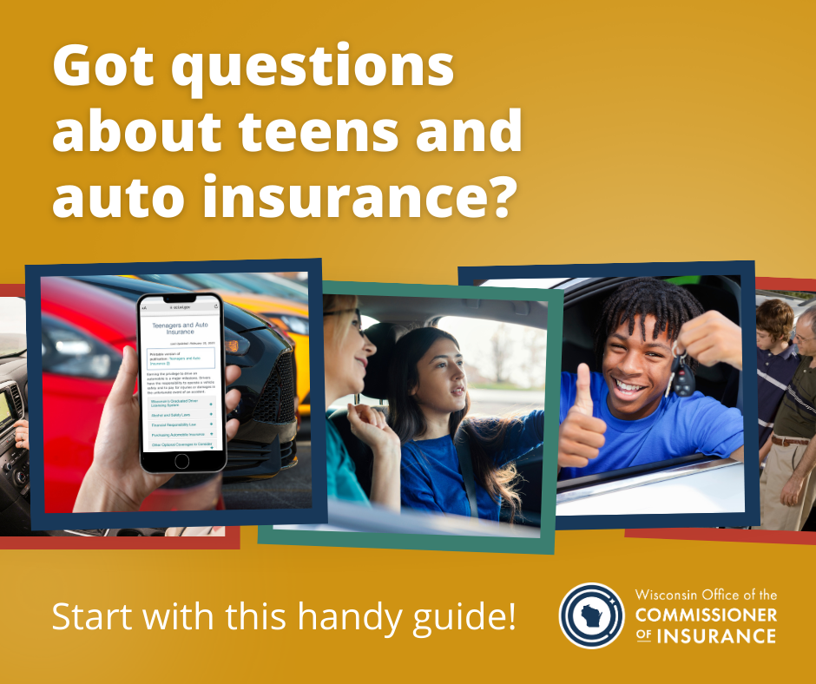

Social text:
So your teen is ready to get behind the wheel...
This major milestone is often accompanied by some anxiety for parents and their new drivers. Luckily, the insurance experts at @wisconsinoci offer a handy guide to Teens and Auto Insurance. Read it here: http://oci.wi.gov/TeenAuto 🚗
Social text:
Whether you just picked up the keys to your dream house, or you're still navigating a competitive market, don't wait to educate yourself about homeowners insurance!
The insurance experts at @wisconsinoci have made it easy with this FAQ guide: oci.wi.gov/HomeIns 🏡

Social text:
Here in the dairy state, over 11% of our working population is employed by the agriculture industry. Farmers and their families have unique insurance needs, and the experts at @wisconsinoci are here to offer a few helpful tips. Read more here: oci.wi.gov/FarmOwners 🌾

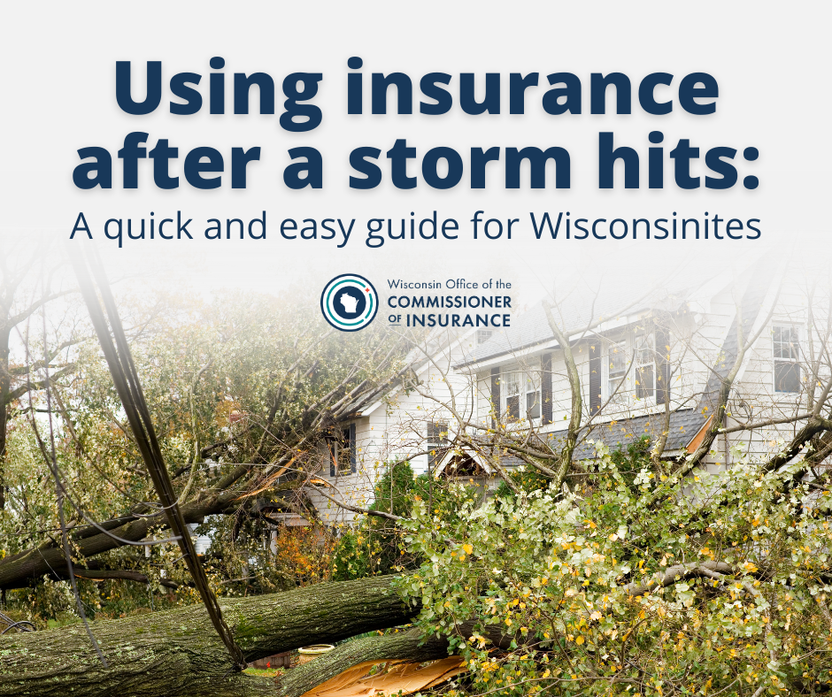

Social text:
Let's face it: nobody looks forward to making an insurance claim. But when storms move into town, you may not have a choice. The experts at @wisconsinoci are here to ease the process with their tips for filing an insurance claim after a storm. Read here: oci.wi.gov/AfterStorm ⛈️
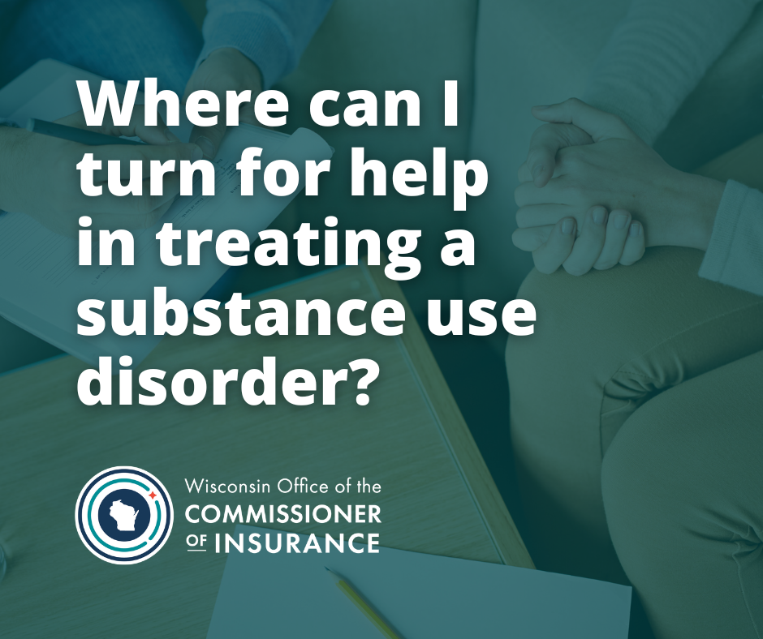

Social text:
Many communities in our state are facing the pain of addiction and overdose. It’s important to remember that there are many pathways to #recovery, including free resources and treatment covered by insurance. Get started with this guide from @wisconsinoci: oci.wi.gov/SubsUseTreatment

Social text:
Insurers and insurance producers often have access to highly sensitive consumer financial and health information. If your data has been compromised in a cybersecurity breach, you have rights. Learn how you're protected here: oci.wi.gov/Cybersecurity @wisconsinoci
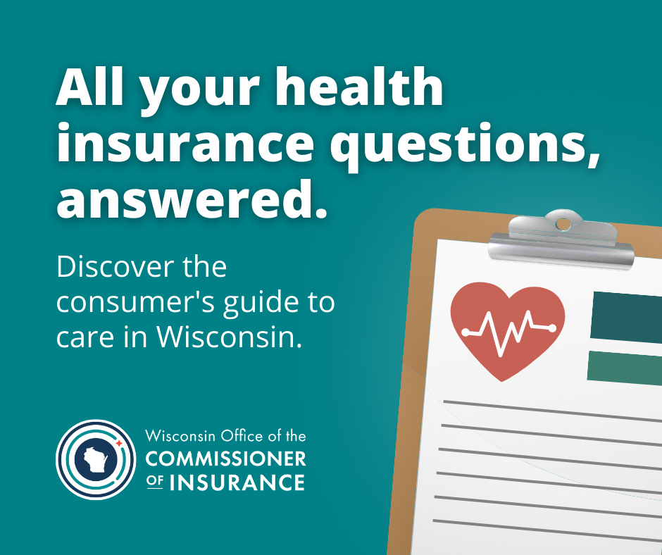

Social text:
You don't have to be an expert to make an informed decision about your health insurance, but a little expert help can't hurt! This guide from @wisconsinoci has everything consumers need to know: oci.wi.gov/HealthInsGuide

Social text:
There are a few things everyone should know before signing up for Medicare Part D. Are you up to date with the latest information? Find everything you need to know here, courtesy of the insurance experts at @wisconsinoci: oci.wi.gov/MedicarePartD

Social text:
In Wisconsin, small businesses play a big role in uplifting local communities and economies. Whether you're a new entrepreneur or Main Street mainstay, don't forget to consider your insurance needs. The experts at @wisconsinoci have all you need to know: oci.wi.gov/SmBusiness

